Manual 11-The Budget Allocated to each Agency

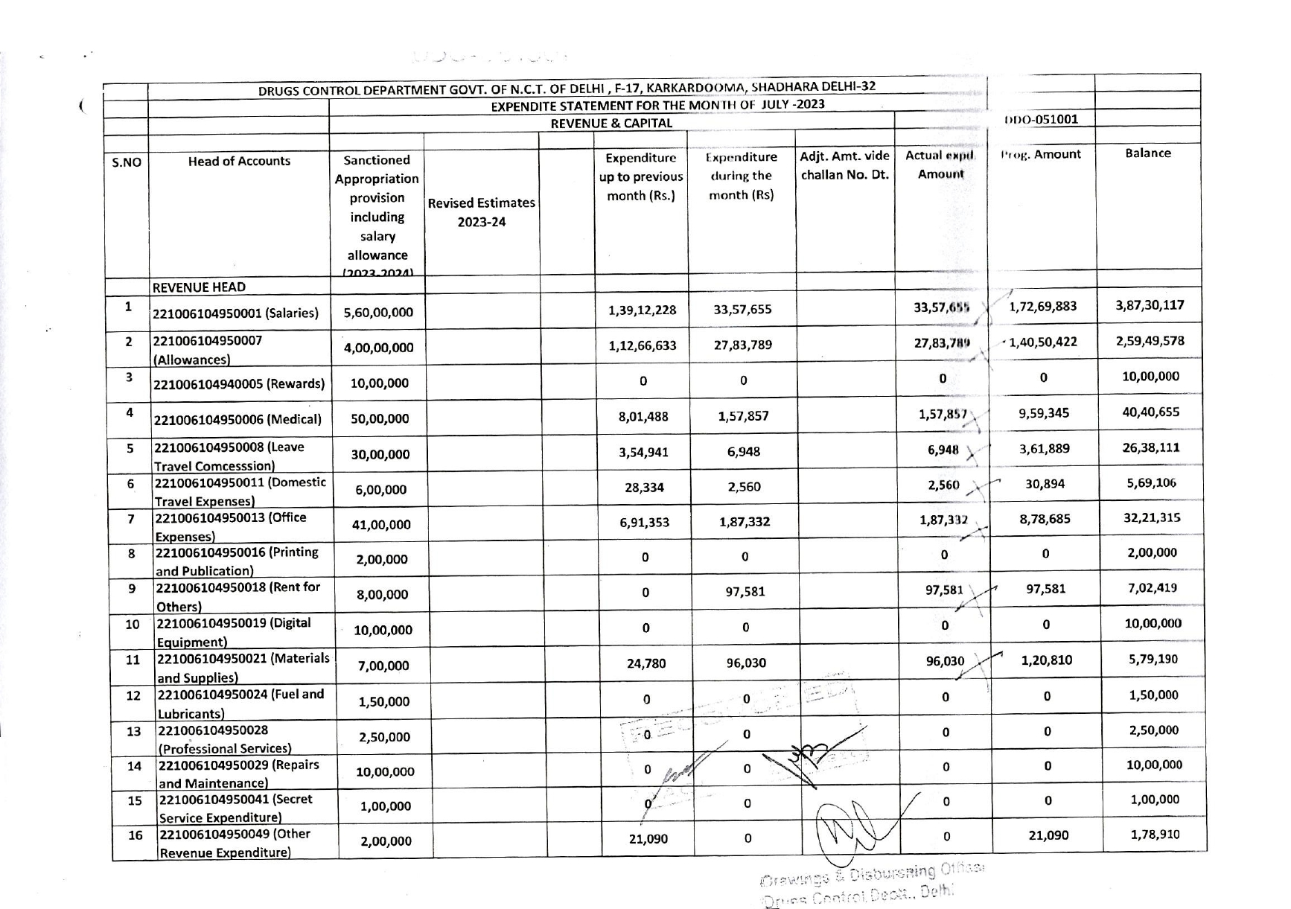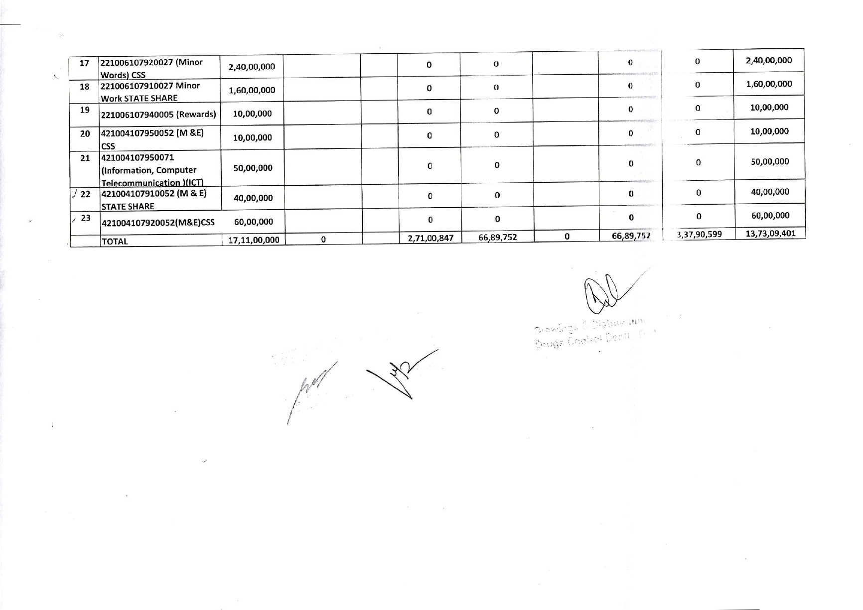

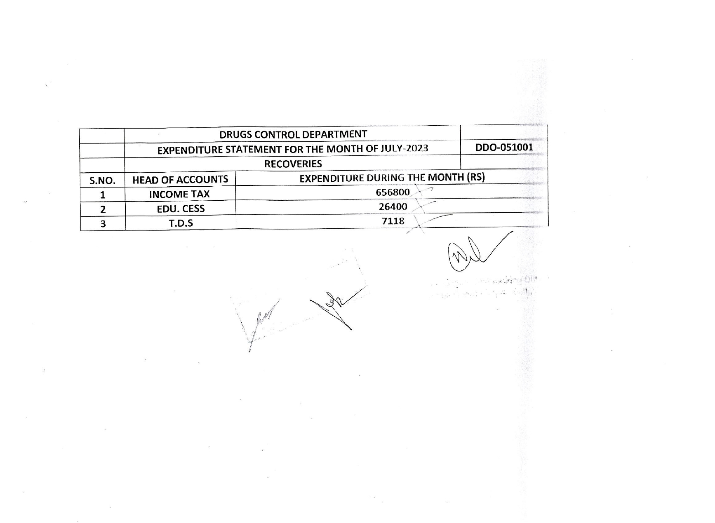

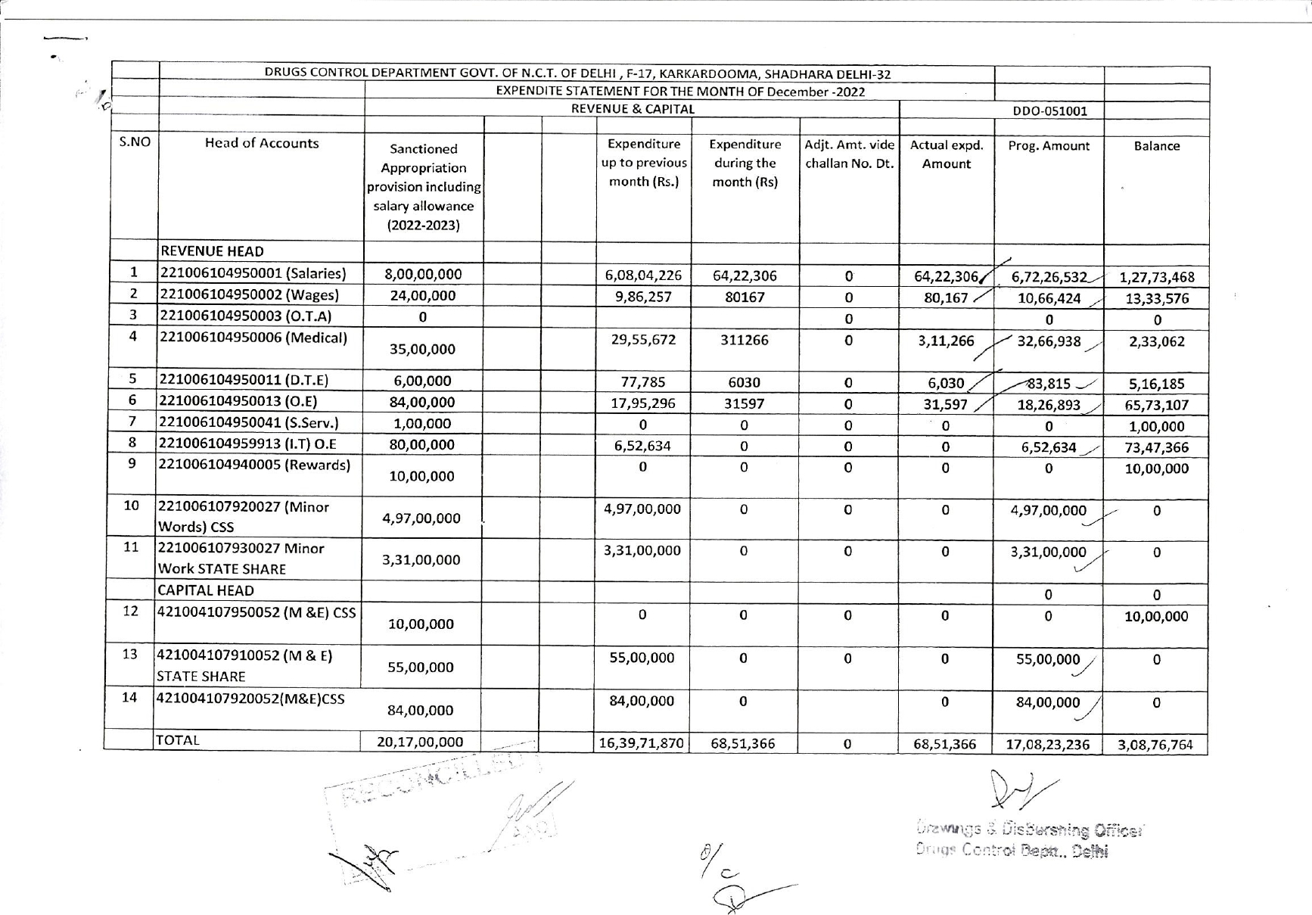

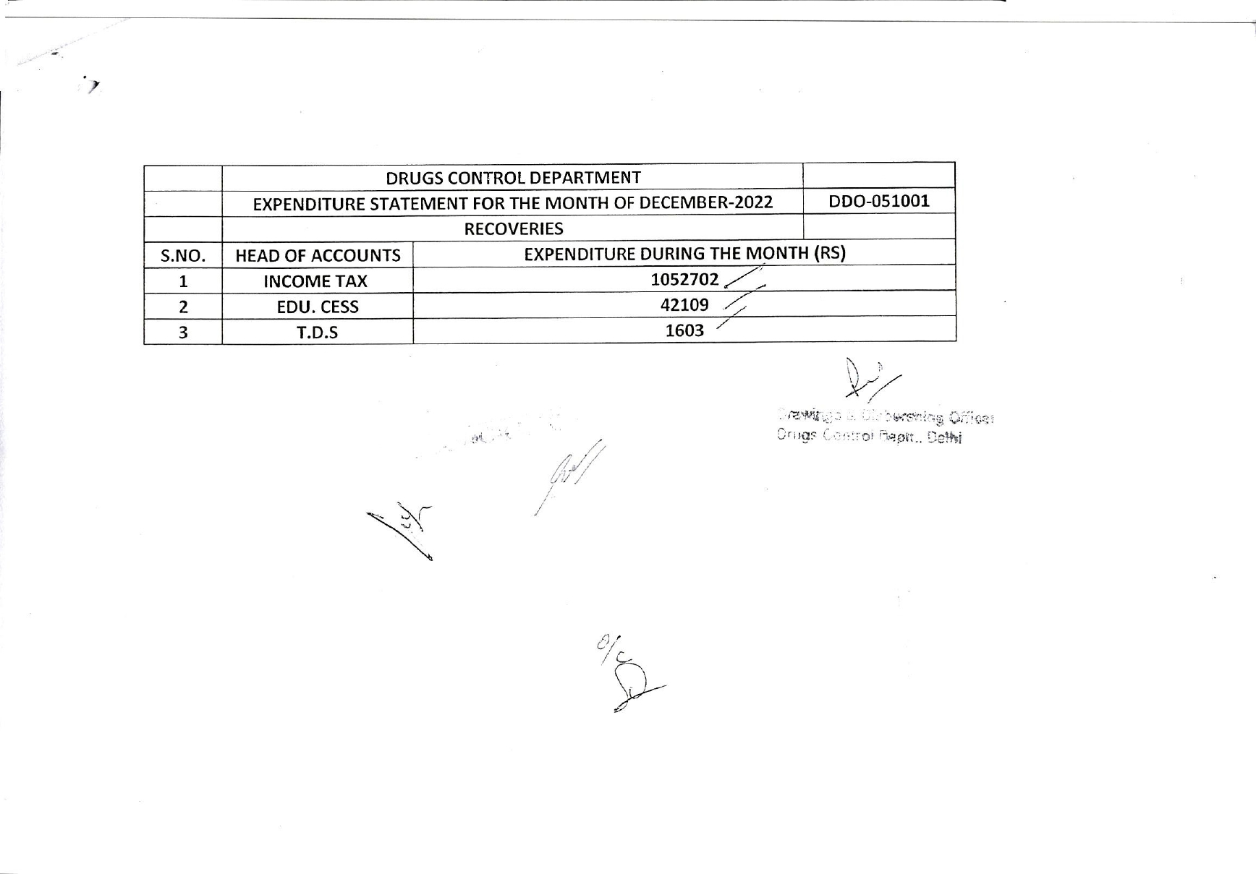

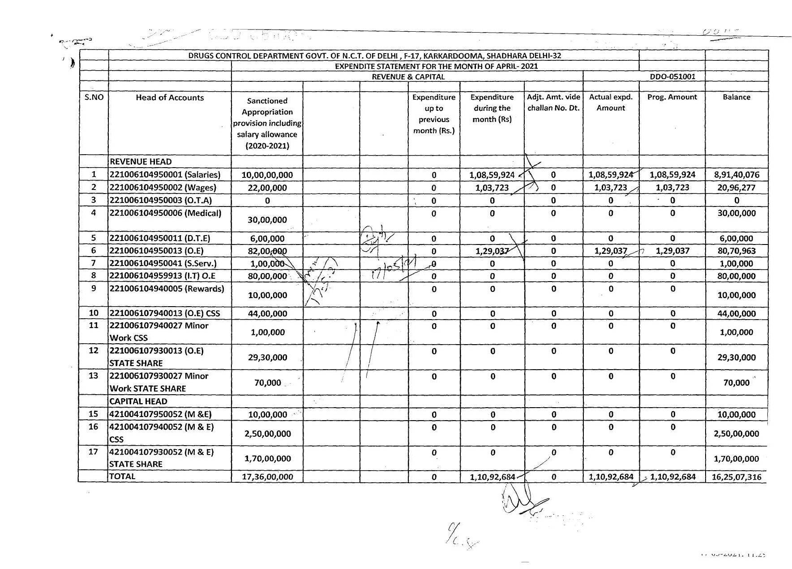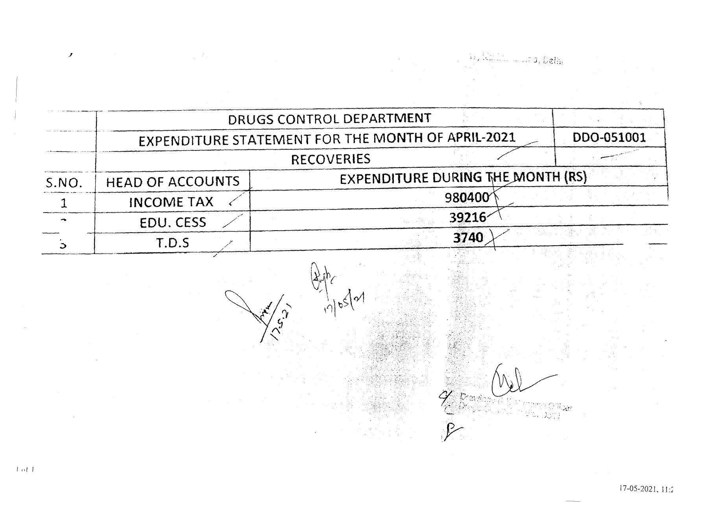

Year 2004-2005
S.No. | Name of the scheme/head | Activity | Starting date of the activity | Planned end date of the activity | Amount proposed(Rs. In lacs) | Amount sanctioned(Rs. In lacs) | Amount released/disbursed (No. of installments)(Rs, in lacs) | Actual expenditure for the last year(Rs, in lacs) | Responsible officer for the quality and the complete execution of the work
1. | 2. | 3. | 4. | 5. | 6. | 7. | 8. | 9. | 10.
1. | Strengthening of Drugs Control Department | (i) (i) Office Expenses (Advertisements, Telephone, Electricity and other expenditures(O.E. Non-Plan)  (ii) Purchase of chemicals and Lab. Equipments(O.E. Plan) | 01/04/10  01/04/10  2016 | 31/03/11  31/03/11  2017 | 30.00(B.E.)  70.00(B.E.) | Awaits | 3.64(as on 30-06-2016)  5.04 (as on 30-06-2016) |  | Sh. K. C. Aggarwal , Head of Office

